horizontal line

**Just Great Games International**

30 Patten Road

Westford, MA 01886

(978) 512-4992

Battleship

**21st May 2018**

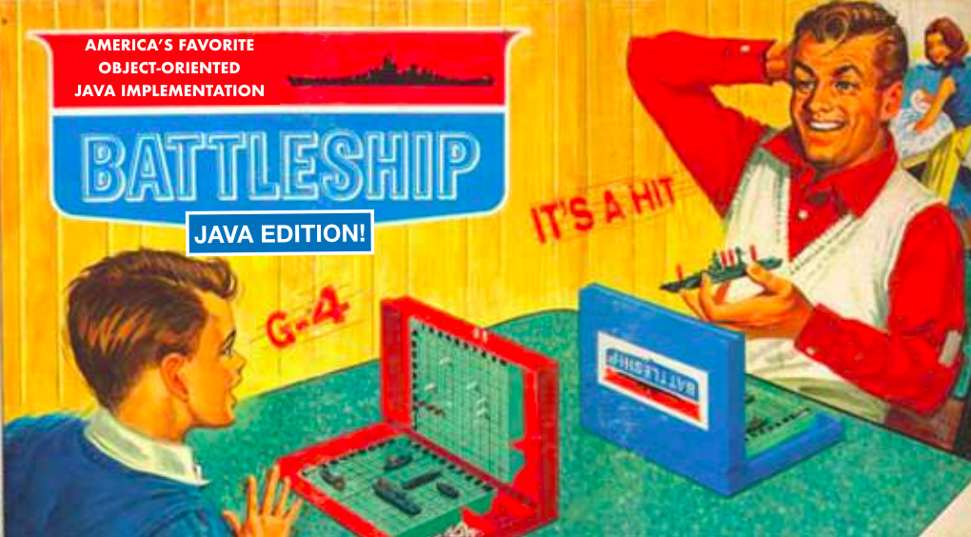

Dear Mr. Geary,

The purpose of this letter is to propose a new online game for your company to internationally distribute. Our overall intent is to computerize the family favorite board game Battleship, with the Harry Potter edition implemented. Players can enjoy searching their opponent’s board for a variety of Harry Potter themed transportation, with the Hogwarts Express and Knight Bus being two of the featured modes. After arranging their modes of transportation around a variety of notable locations from the popular series, players alternate turns to find and jinx their opponent’s boats. Players will cast *Aparecium* spells to reverse the concealment spells placed on their adversary’s transportation, each spell revealing one grid square. Below you will find more specific details outlining our proposal; we hope you will choose our game to distribute and look forward to hearing from you in the near future.

Sincerely,

Marcos Acosta, Ani Balasubramanian, Renee Sawka

**Renee.Ani.Marcos. (RAM) Co., Ltd.**

# OVERVIEW

We will be building a computer game version of the traditional family game Battleship. It will be programmed to be able to be played against both the computer and another player at the same computer. The computer will have different settings of difficulty (described below) to give a sufficient challenge to the player. Other implementations not necessarily in the game may also be added as the project is being developed.

# GOALS

1. To build a single player version of the game with multiple difficulty levels to play against.
2. To allow for two people to play the game against each other similar to the board version (pass-and-play functionality)

# Design of Program

Edition

In all available play modes, there will 4 pieces of transportation for players to use on a standard 8x8 grid.

1. Nimbus 2000 - 2 grid squares
2. Flying Ford Anglia - 3 grid squares
3. Knight Bus - 4 grid squares
4. Hogwarts Express - 5 grid squares

Single Player:

1. Game starts
2. The player is allowed to place his pieces and jinx
3. The AI randomly places its pieces and jinxes
4. Player and AI take turns selecting locations to spell and being alerted of misses, hits, and sinks, updating the board accordingly
5. AI strategy:
   1. Easy: fires at random
   2. Medium: fires at only diagonal squares until a ship is found, then fires around it until determining the direction and fires in that line until the ship is sunk
   3. Hard: same strategy as medium, also taking into consideration the size of ships
6. If all targets on a ship have been hit, it sinks and notifies the player
7. Once all ships for the player or AI have been sunk, a winner is declared and a reward screen is shown
8. The game is allowed to be reset

Two Player:

1. Game starts
2. One player and then the other are allowed to place their boats and bomb
3. Players take turns selecting locations to fire and being alerted of misses, hits, and sinks, updating the board accordingly
4. If all targets on a ship have been hit, it sinks and notifies the players
5. Once all ships for a player have been sunk, a winner is declared and a reward screen is shown
6. The game is allowed to be reset

# Division of Labor

All: groundwork, integration of parts

Ani: Player design, assist with GUI and AI design  
Marcos: AI design, assist with GUI and Player design  
Renee: GUI design, assist with Player and AI design

Sample Board:

